eCMS MANUAL

Decleration Approval

Department of Revenue and Customs
Ministry of Finance

Table of Contents
1. Introduction 1
2. Logging in as Custom Officer 1
3. Approve Declaration 2
3.1. Search Customs Submitted Declaration 2
3.2. Search Declaration: 2
3.3. Approve Declaration 3
3.4. Search and Approve Amendment 4
3.5. Search and Approve Cancellation 4
3.6. Search and Approve Transit Amendment 5
3.7. Search and Approve Post Entry Cancellation 5
3.8. Create Declaration 6
3.9. Search Declaration Audit 6
3.10. Amendment by Customs 7

Introduction

The Custom Official has the right to approve the application that has been submitted by the Front-end user. This document provides you the guide for approval of Manifest and Declaration in the eCMS.

Logging in as Custom Officer

- The user needs to log into eCMS using the url: www.ecms.gov.bt
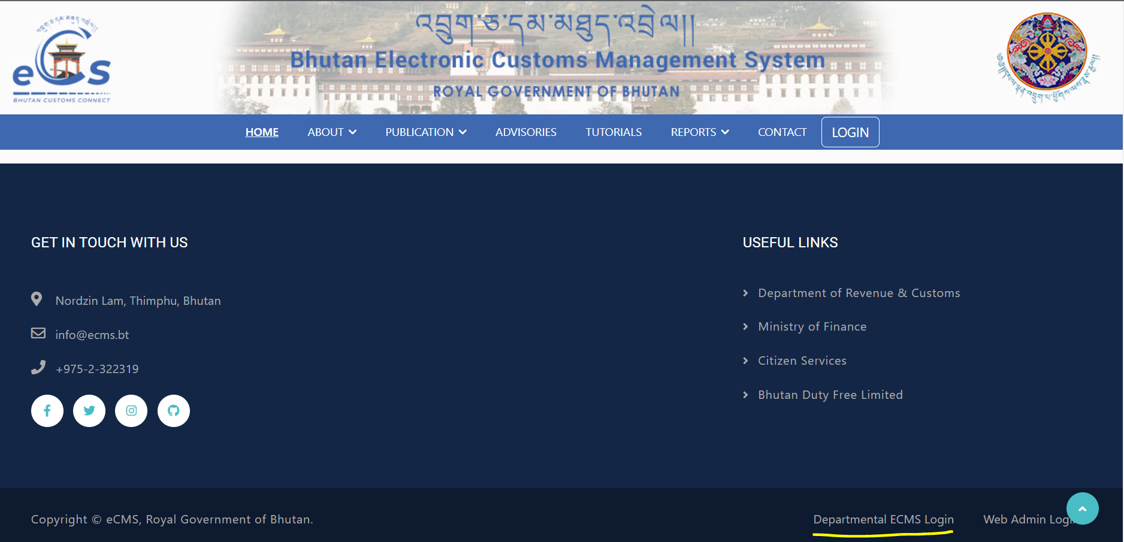
- Click on login menu and provide the required credentials to log in to the system:

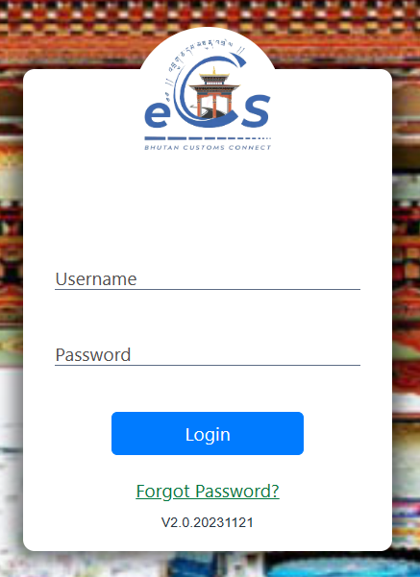

Approve Declaration
- Click on the menu Declaration CMS

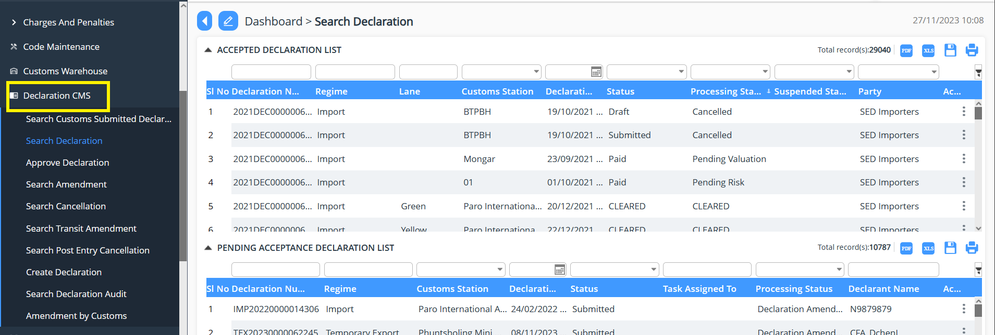

Search Customs Submitted Declaration

- Go to Declaration menu and click on “Search Declaration”.
- List of declaration that has been submitted and in draft listed under the Custom user.
- The declaration under the draft state can be edited and submitted.
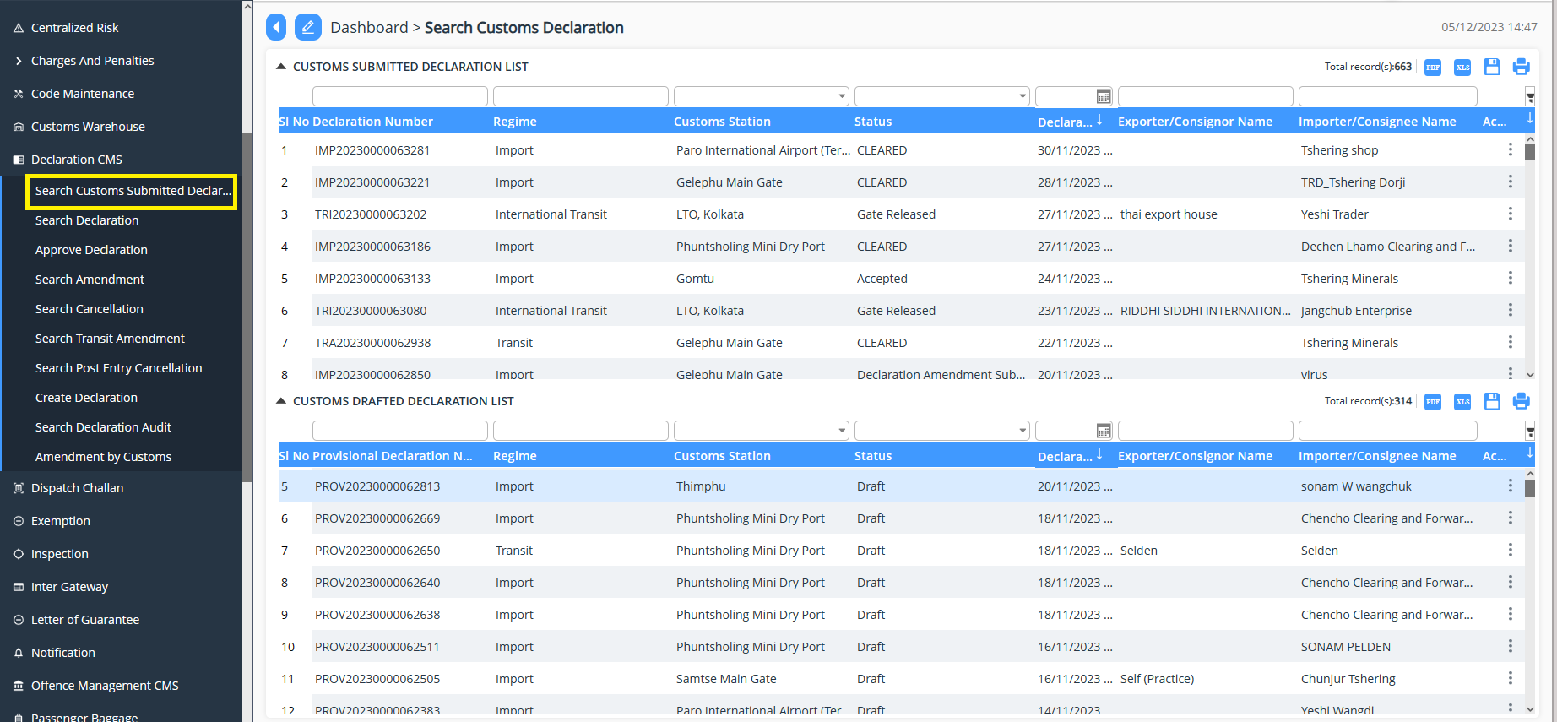

Search Declaration:

- Go to Declaration menu and click on “Search Declaration”.
- List of declaration that has been submitted and listed under the particular Custom user.
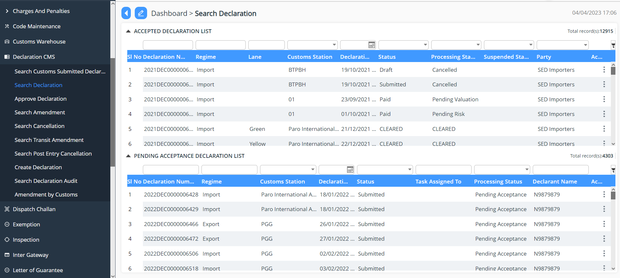

Approve Declaration

- Go to Declaration menu and click on “Approve Declaration”.
- Search for the declaration reference number if the number is known/ the Custom user will be doing there due diligent but working on the day-to-day application received.
- The Custom user will then validate the declaration under each menu to validate the detail submitted by the FE user.
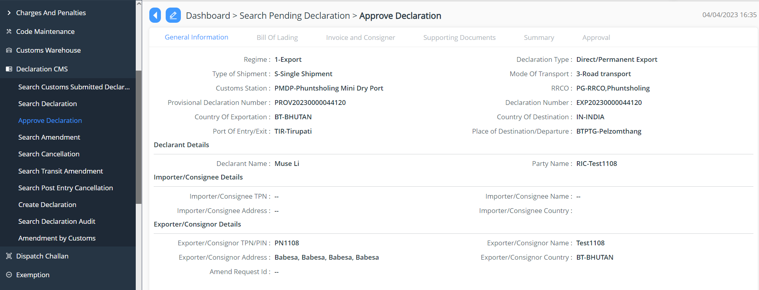

- Once the review is completed the focal will have the option to do the following to the declaration:

- Approve: the application is reviewed and approved
- Reject: the application gets rejected due to certain reasons; the reason will be then provided in remarks.
- Reject for amendment: due to certain missing details the application will be send back for amendment.
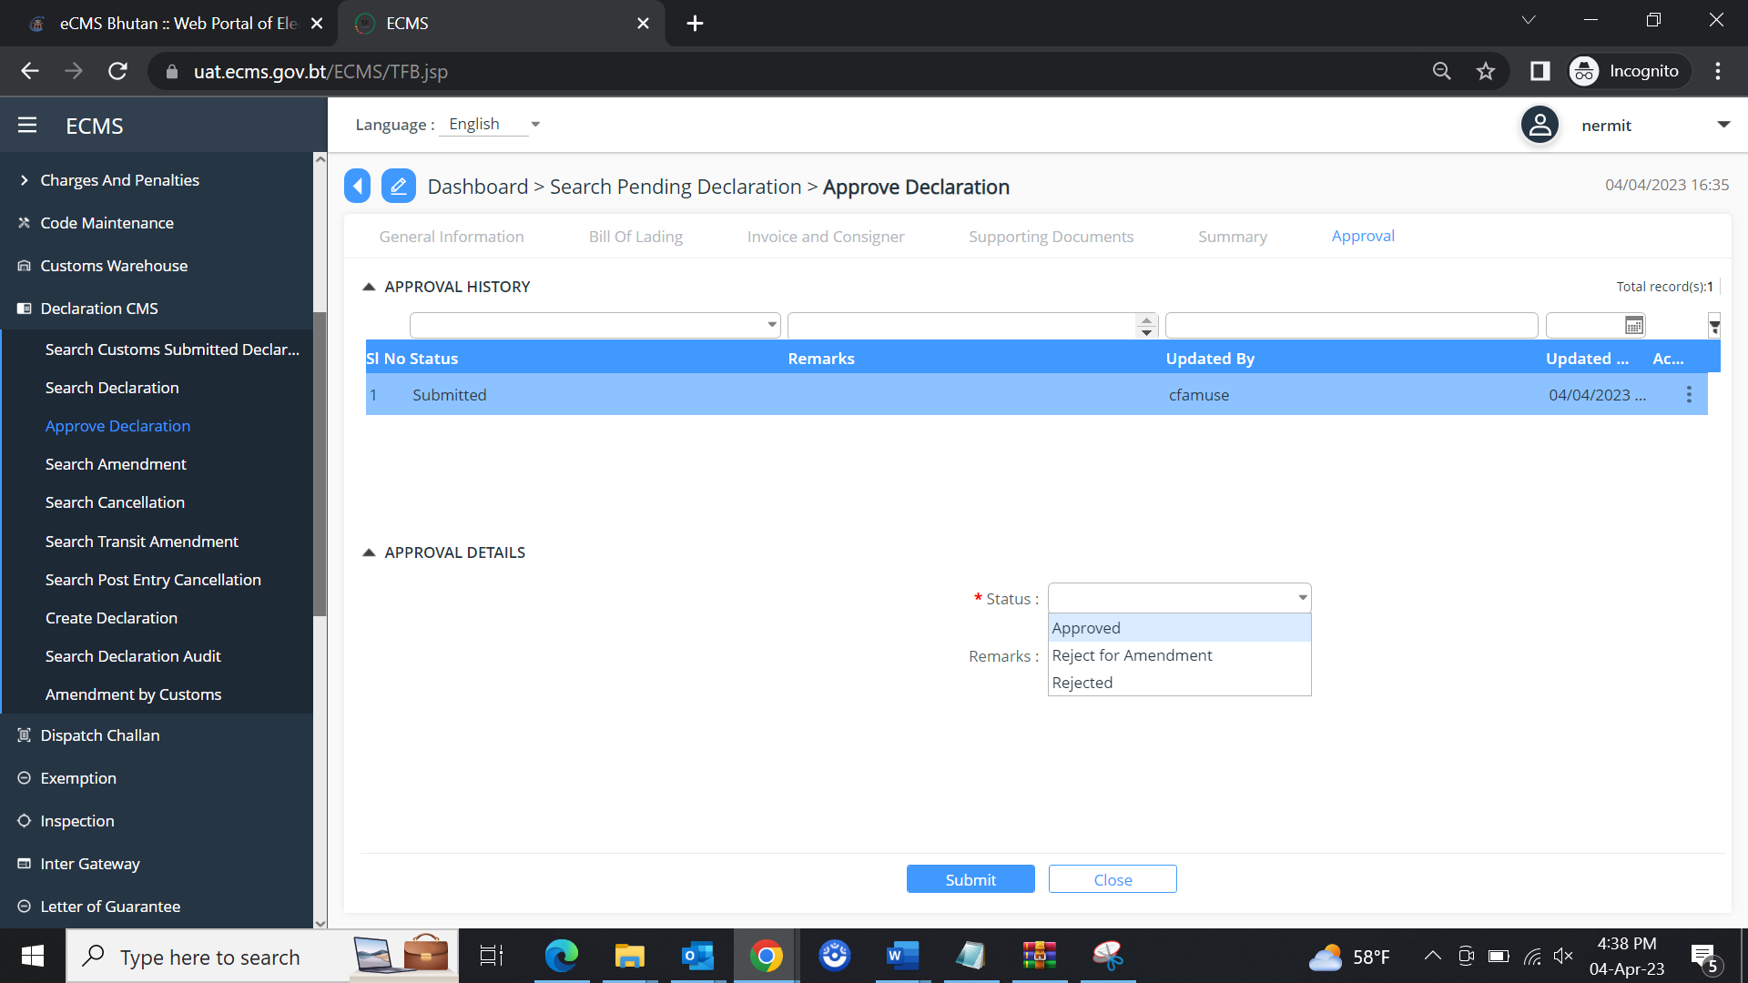

Search and Approve Amendment
- Go to Declaration menu and click on “Search Amendment”.
- Take the declaration reference number for amendment.
- The Custom user will then validate the amendment declaration under each menu to validate the detail submitted by the FE user.

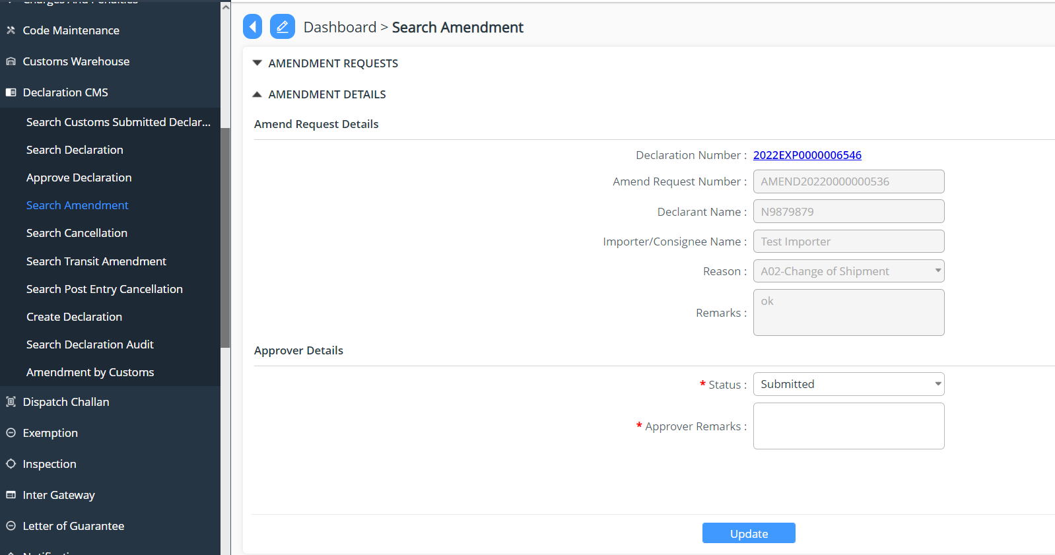

Search and Approve Cancellation
- Go to Declaration menu and click on “Search Cancellation”.
- Take the declaration reference number for cancellation request.
- The Custom user will then validate the amendment declaration under each menu to validate the detail submitted by the FE user.
- Here the Officer can do the following with the declaration:
  - Approved: Approve the cancellation request
  - Reject: Reject the cancellation request
  - Submitted: Submitted state

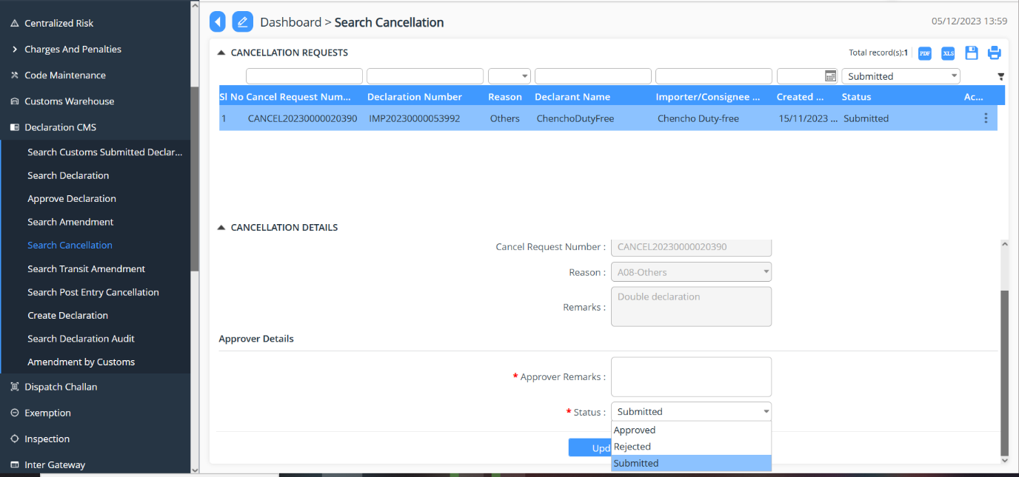

Search and Approve Transit Amendment
- Go to Declaration menu and click on “Search Transit Amendment”.
- Take the declaration reference number for cancellation request.
- The Custom user will then validate the amendment declaration under each menu to validate the detail submitted by the FE user.
- Here the Officer can do the following with the declaration:
- Approved: Approve the cancellation request
- Reject: Reject the cancellation request
- Submitted: Submitted state
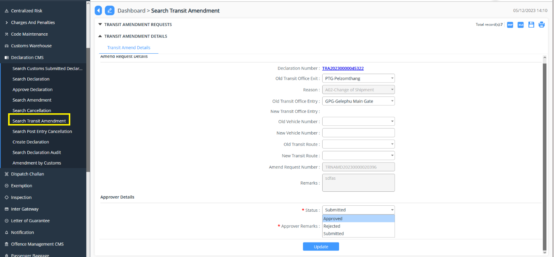

Search and Approve Post Entry Cancellation
- Go to Declaration menu and click on “Search Post Entry Cancellation”.
- Take the declaration reference number for cancellation request.
- The Custom user will then validate the amendment declaration under each menu to validate the detail submitted by the FE user.
- Here the Officer can do the following with the declaration:
- Approved: Approve the cancellation request
- Reject: Reject the cancellation request
- Submitted: Submitted state
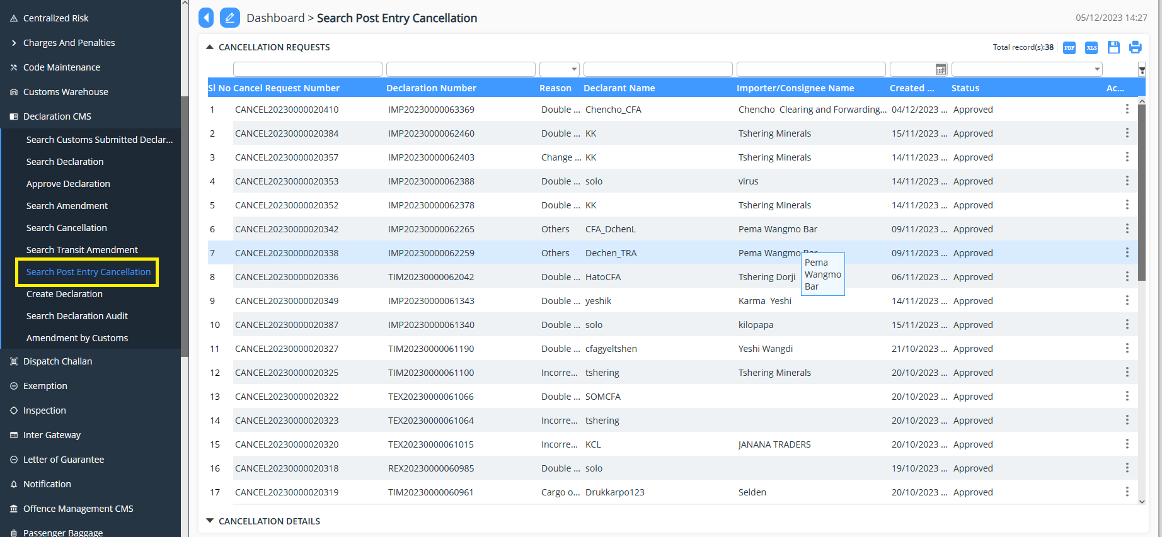

Create Declaration
- Go to Declaration menu and click on “Create Declaration”.
- Cust user also has the right to create declaration required by the Cust as per their requirement.
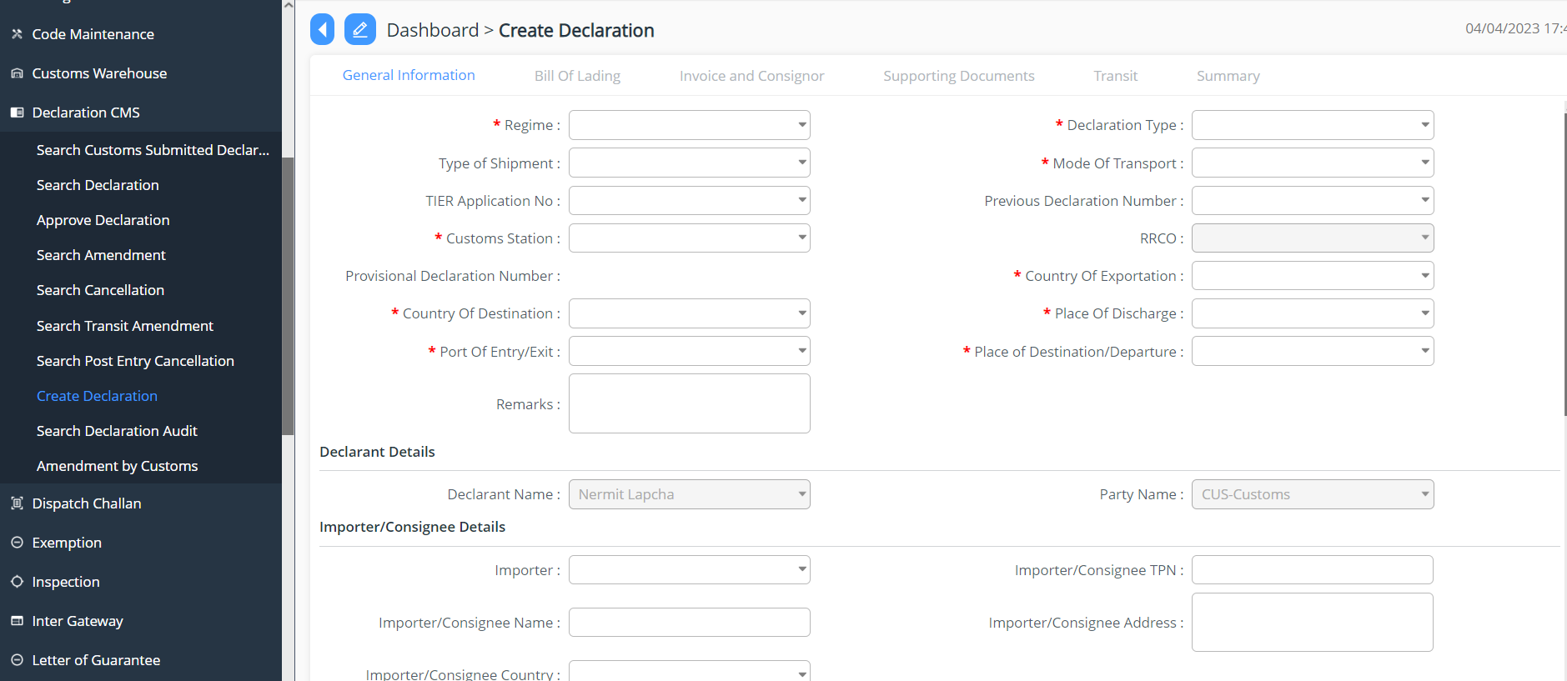

Search Declaration Audit
- Go to Declaration menu and click on “Search Declaration Audit”.
- List of declaration that has been submitted and listed under the Custom user.
- Based on the parameter the list can be populated.
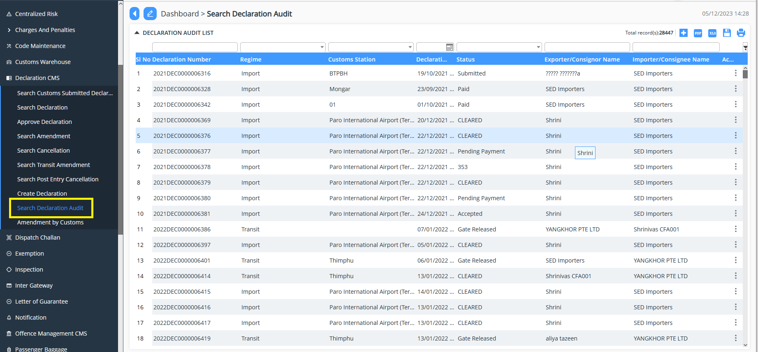

Amendment by Customs
- Go to Declaration menu and click on “Amendment by Customs”.
- List of declaration that has been submitted and listed under the Custom user.
- Select the declaration that needs amendment, do the necessary changes, and update the same.
